Title: Supporting Information

for
Title here

Author#1, Author#2, Author#3, and Chun-Hu Chen*
Department of Chemistry, National Sun Yat-sen University, Kaohsiung, Taiwan 80424
E-mail: chunhu.chen@mail.nsysu.edu.tw

Material synthesis
[Example] Synthesis of graphene oxide (GO)
Graphene oxide was synthesized using preformed acidic oxidizing medium (PAOM)…

[Example of data presentation] Figure S-2: The XRD pattern of …..
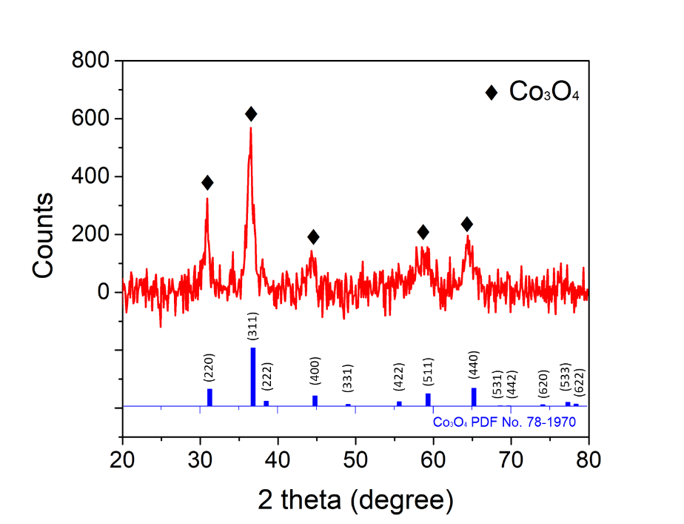

[Example of Table] Table S-1: The Tafel plots of …..

Sample |  |  | Tafel slope (mV/dec)
Co:Mn= 1:3 |  |  |  | 64.0
Co:Mn= 1:1 |  |  |  | 62.9
Co:Mn= 3:1 |  |  |  | 62.0
Co:Mn= 5:1 |  |  |  | 61.2
Co:Mn= 7:1 |  |  |  | 60.9
Co:Mn= 9:1 |  |  |  | 77.8

[Example of Table compaison] Table S-2: The OER performance comparison between A and the reported B.
Sample |  | Onset potential (V) | Potential  @10 mA cm⁻² |  | Electrolyte |  | Reference
CoPi |  | 1.64 | -- |  | 0.1 M KPi |  | 1
Ni_{0.9}Fe_{0.1}O_{x} |  | 1.53 | 1.57 |  | 1 M KOH |  | 2
Mn₂O₃ |  | -- | 1.81 |  | 0.1 M KOH |  | 3
FeCoNiO_{x} |  | 1.42 | -- |  | 0.1 M KOH |  | 4
Fe₄₀Co₄₀Ni₂₀O_{x} |  | 1.42 | -- |  | 0.1 M KOH |  | 5
Mn₂O₃ |  | 1.40 | -- |  | 1 M KOH |  | 6
NiFe/NF |  | 1.43 | -- |  | 0.1 M KOH |  | 7
Mn/Co-CB |  | 1.45 | -- |  | 0.1 M KOH |  | 8
CoO_{x}–CoSe |  | 1.50 | -- |  | 1 M KOH |  | 9
Cu₃P |  | 1.60 | -- |  | 0.1 M KOH |  | 10
CMOH |  | 1.28 | 1.62 |  | 0.1 M KOH |  | This work

Reference

